Blockchain and it’s Applications
Question Bank Unit 4 Missing
- Explain and list the part of EVM Memory in blockchain.
Ans. 1) The Ethereum Virtual Machine (EVM) is a crucial component of the Ethereum blockchain network. It is a decentralized virtual machine that enables the execution of smart contracts on the Ethereum platform. The EVM plays a vital role in processing transactions and running decentralized applications (dApps) on the Ethereum network.

Key components of the EVM memory in blockchain include:

1. Stack: The EVM uses a stack-based memory model to store and process data during smart contract execution. The stack is used for temporary storage of data and intermediate results during computation.

2. Memory: The EVM has a memory area that allows smart contracts to dynamically allocate memory during execution. This memory is used for storing data structures and arrays required by smart contracts.

3. Storage: The EVM provides persistent storage in the form of key-value pairs for smart contracts. This storage is more permanent compared to memory and is used to store contract state variables and data that need to persist across multiple transactions.

4. Program Counter (PC): The program counter in the EVM keeps track of the current instruction being executed. It points to the next instruction to be executed and helps in the sequential execution of smart contract code.

5. Gas: Gas is a unit used to measure the computational effort required to execute operations on the Ethereum network. Each operation in the EVM consumes a certain amount of gas, and users need to pay gas fees to execute transactions and smart contracts.

By understanding these components of the EVM memory in blockchain, developers and users can better comprehend how smart contracts are executed and how data is managed within the Ethereum network.

- What is Hyperledger fabric? Explain in detail.
Ans. 2) Hyperledger Fabric is an open-source, enterprise-grade permissioned distributed ledger platform that provides a foundation for developing blockchain-based applications, solutions, and products tailored for use within private enterprises. It is a modular blockchain framework designed to offer flexibility, scalability, and security for business applications. Fabric is maintained by the Linux Foundation's Hyperledger project, which aims to advance cross-industry blockchain technologies.

Key features and characteristics of Hyperledger Fabric include:

1. Permissioned DLT Platform: Fabric is a permissioned blockchain network, meaning that participants must be authenticated and authorized to join the network. This allows for greater control over access, privacy, and governance compared to permissionless blockchains like Bitcoin.

2. Modular Architecture: Fabric's modular architecture enables the customization of various components to suit specific use cases and requirements. It allows for plug-and-play components, such as consensus algorithms and membership services, to be integrated into the network.

3. Smart Contracts: Fabric supports smart contracts written in general-purpose programming languages like Java, Go, and Node.js. This flexibility allows developers to create complex business logic and execute transactions on the blockchain.

4. Emphasis on Ledger, Smart Contracts, Consensus, Confidentiality, Resiliency, and Scalability: Fabric focuses on providing a robust and efficient ledger, supporting smart contract execution, implementing consensus mechanisms, ensuring data confidentiality, maintaining network resiliency, and enabling scalability for enterprise applications.

5. Hyperledger Foundation: Fabric is part of the Hyperledger project under the Linux Foundation, which fosters collaboration among industry leaders to develop open-source blockchain technologies for various business sectors.

6. Continuous Development: Fabric has seen continuous development and improvement since its initial release in July 2017. It has a vibrant community of developers and contributors from various organizations working together to enhance the platform's capabilities.

In conclusion, Hyperledger Fabric is a versatile and powerful blockchain platform designed for enterprise use cases, offering features such as permissioned access, modular architecture, smart contract support, and a focus on scalability and security. It provides a solid foundation for building blockchain applications tailored to the specific needs of businesses in diverse industries.

- Explain Hyperledger sawtooth.
Ans. 3) Hyperledger Sawtooth is another open-source blockchain platform under the Hyperledger project, maintained by the Linux Foundation. Sawtooth is designed to address the scalability and security challenges faced by distributed ledger technologies, offering a flexible and modular architecture for building and deploying blockchain applications. Here are some key aspects of Hyperledger Sawtooth:

1. Modular Design: Sawtooth features a modular design that allows for the customization of consensus algorithms, permissioning systems, and smart contract execution engines. This modularity enables developers to tailor the platform to specific use cases and requirements.

2. Consensus Mechanisms: Sawtooth supports multiple consensus algorithms, including Practical Byzantine Fault Tolerance (PBFT), Proof of Elapsed Time (PoET), and others. This flexibility allows network participants to choose the consensus mechanism that best suits their needs.

3. Smart Contracts: Similar to Hyperledger Fabric, Sawtooth supports smart contracts written in popular programming languages like Python and JavaScript. These smart contracts can be used to define the business logic and rules for transactions on the blockchain.

4. Scalability: Sawtooth is designed to be highly scalable, with features such as parallel transaction processing and dynamic consensus. This scalability is essential for supporting large-scale enterprise applications with high transaction volumes.

5. Permissioned Network: Sawtooth can be configured as a permissioned network, where participants are authenticated and authorized to access the blockchain. This permissioning model provides greater control over data privacy and network governance.

6. Hyperledger Foundation: Sawtooth is part of the Hyperledger project, which focuses on developing open-source blockchain technologies for enterprise use cases. The project fosters collaboration among industry leaders to advance blockchain adoption across various sectors.

7. Continuous Development: Sawtooth is actively developed and maintained by a community of contributors from different organizations. Regular updates and enhancements ensure that the platform remains secure, reliable, and up-to-date with the latest blockchain innovations.

In summary, Hyperledger Sawtooth is a versatile and scalable blockchain platform with a modular architecture, support for multiple consensus algorithms, smart contract capabilities, and a focus on enterprise-grade applications. It provides a robust foundation for building and deploying blockchain solutions tailored to the specific needs of businesses in various industries.

- Draw and explain fabric architecture.
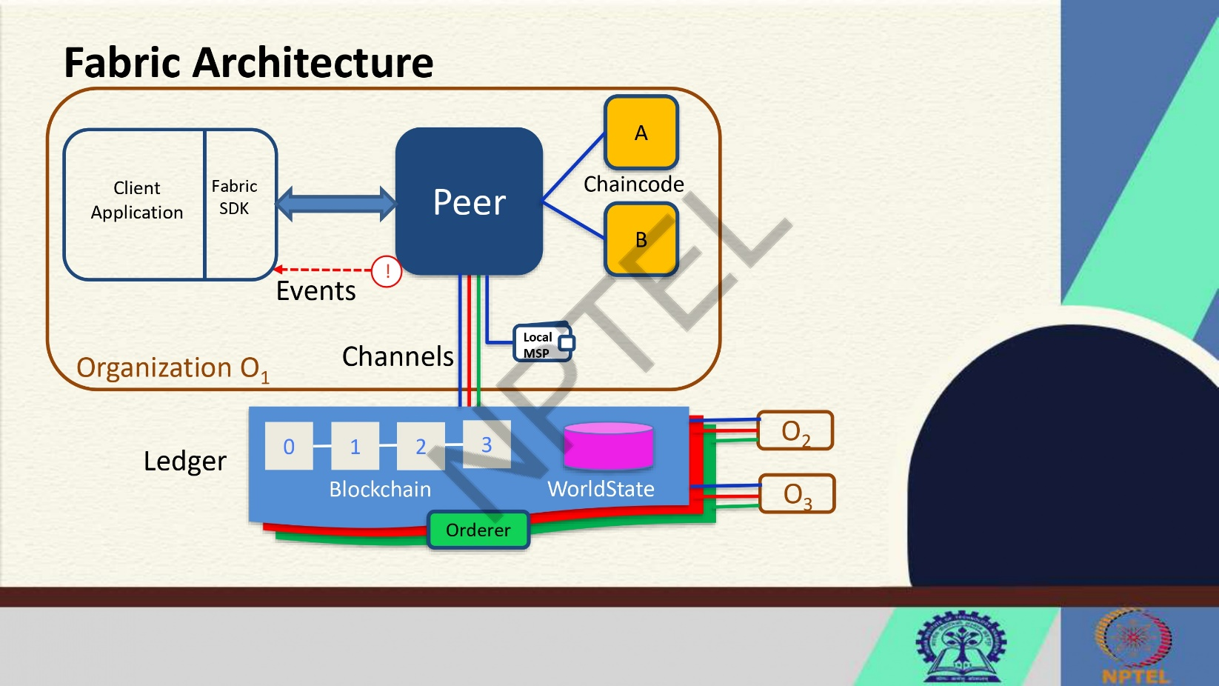
Ans. 4)

The architecture of Hyperledger Fabric is designed to provide a flexible and modular framework for building enterprise-grade blockchain applications. Below is an overview of the key components and their interactions in the Fabric architecture:

1. Peer Nodes: Peer nodes maintain a copy of the ledger and execute transactions. There are two types of peer nodes: endorsing peers, which simulate transactions and create proposals, and committing peers, which validate transactions and update the ledger.

2. Ledger: The ledger consists of two main components: the blockchain and the world state. The blockchain stores a sequential record of transactions, while the world state represents the current state of the ledger after applying all transactions.

3. Chaincode: Chaincode, also known as smart contracts, contains the business logic for processing transactions. It is executed by peer nodes and can be written in general-purpose languages like Java, Go, and Node.js.

4. Channels: Channels are used to partition the network and restrict transaction visibility to specific participants. They enable private and confidential transactions between selected parties on the network.

5. Local Membership Service Provider (MSP): MSP manages the identities of network participants and enforces access control policies. It authenticates users and ensures that only authorized entities can interact with the blockchain network.

6. Client Application: Client applications interact with the blockchain network by submitting transaction proposals, querying the ledger, and receiving transaction results. They communicate with peer nodes to execute transactions.

7. Fabric SDK: The Fabric Software Development Kit (SDK) provides tools and libraries for developers to build applications that interact with the Fabric network. It simplifies the process of integrating blockchain functionality into existing systems.

8. Events: Events are notifications triggered by specific actions on the blockchain, such as the completion of a transaction or the update of the ledger. Clients can subscribe to events to receive real-time updates from the network.

9. Orderer Node: The orderer node is responsible for reaching consensus on the order of transactions and creating blocks to be added to the blockchain. It ensures that transactions are executed in a deterministic and consistent manner across the network.

10. Organization (O): Organizations represent entities that participate in the blockchain network. Each organization may consist of multiple peer nodes and has its own MSP for managing identities and access control.

The Fabric architecture provides a robust foundation for developing scalable, secure, and customizable blockchain applications tailored to the specific requirements of enterprise use cases. By leveraging its modular design and pluggable components, developers can create sophisticated solutions that address a wide range of business challenges.

- Differentiate between PoW Consensus vs BFT Consensus.
Ans. 5)
Criteria | PoW Consensus | BFT Consensus
Type | Permissionless | Permissioned
Finality | Probabilistic | Deterministic
Scalability | Limited | Better scalability in terms of transaction throughput and confirmation speed
Energy Efficiency | High energy consumption | Lower energy consumption
Security | Highly secure but vulnerable to 51% attacks | Highly secure against Byzantine faults
Speed | Slower due to competition for block creation | Faster due to known participants and quorum requirements
Trust Model | Trustless system with economic incentives | Trust among known participants
Use Cases | Bitcoin and other public blockchains | Enterprise blockchain networks
In summary, Proof of Work (PoW) consensus is typically used in permissionless, public blockchains like Bitcoin, offering high security at the cost of energy consumption and scalability. On the other hand, Byzantine Fault Tolerance (BFT) consensus is commonly employed in permissioned, enterprise blockchains like Hyperledger Fabric, providing faster transaction speeds, lower energy consumption, and deterministic finality with a focus on known participants and trust among them.
Pow vs BFT in detail
Criteria | Proof of Work (PoW) Consensus | Byzantine Fault Tolerance (BFT) Consensus
Type | Permissionless | Permissioned
Participants | Miners compete to solve cryptographic puzzles to validate transactions and create new blocks | Known and trusted nodes participate in the consensus process
Finality | Probabilistic - multiple confirmations are required for transaction finality | Deterministic - once a quorum of nodes agrees on a transaction, it is considered final
Scalability | Limited scalability due to the competitive nature of mining and block creation | Better scalability in terms of transaction throughput and confirmation speed
Energy Efficiency | High energy consumption for solving complex puzzles | Lower energy consumption as there is no need for competitive mining
Security | Highly secure against double-spending attacks but vulnerable to 51% attacks | Highly secure against Byzantine faults and collusion attacks
Speed | Slower due to the time required to solve cryptographic puzzles | Faster due to known participants and quorum requirements for agreement
Trust Model | Trustless system with economic incentives for honest behavior | Trust among known participants with established identities
Use Cases | Public blockchains like Bitcoin, Ethereum | Enterprise blockchain networks like Hyperledger Fabric
In summary, Proof of Work (PoW) consensus is commonly used in permissionless, public blockchains where participants compete to validate transactions, while Byzantine Fault Tolerance (BFT) consensus is prevalent in permissioned, enterprise blockchains where known and trusted nodes collaborate to achieve agreement on transactions efficiently and securely.

- Explain the blockchain performance triangle.
Ans. 6) The blockchain performance triangle is a concept that illustrates the inherent trade-offs between three fundamental aspects of blockchain systems: decentralization, security, and scalability. Let's delve deeper into each component of the blockchain performance triangle:

1. Decentralization:
Decentralization is a core principle of blockchain technology that aims to distribute control and decision-making across a network of nodes, eliminating the need for a central authority. A decentralized blockchain network offers benefits such as censorship resistance, increased transparency, and enhanced trust among participants. However, achieving high levels of decentralization can lead to challenges such as slower transaction processing speeds, higher resource requirements, and potential scalability issues.

2. Security:
Security is paramount in blockchain systems to ensure the integrity, confidentiality, and availability of data stored on the ledger. Security measures such as cryptographic algorithms, consensus mechanisms, and network validation protocols are implemented to protect against various threats like double-spending attacks, Sybil attacks, and 51% attacks. Enhancing security in a blockchain network involves robust encryption techniques, secure key management, and resilient consensus algorithms. However, strengthening security measures may introduce complexities that impact scalability and decentralization.

3. Scalability:
Scalability refers to the ability of a blockchain network to handle a growing number of transactions efficiently without compromising performance. A scalable blockchain can process a high volume of transactions per second, enabling widespread adoption and usability. Achieving scalability involves optimizing network throughput, transaction confirmation times, and block size limits. However, scaling a blockchain network can pose challenges related to network congestion, increased storage requirements, and potential centralization risks.

The blockchain performance triangle highlights the interplay between decentralization, security, and scalability, emphasizing that improvements in one aspect may come at the expense of others. Balancing these three components is crucial for designing a robust and efficient blockchain system that meets the requirements of specific use cases and stakeholders.

Blockchain developers and researchers continuously explore innovative solutions to address the trade-offs within the blockchain performance triangle, seeking to optimize performance while upholding the core principles of decentralization, security, and scalability. By understanding the complexities of the blockchain performance triangle, stakeholders can make informed decisions when designing, implementing, and evaluating blockchain solutions for various applications and industries.

- What are the function modifiers in solidity?
Ans. 7) In Solidity, function modifiers are special keywords that can be used to modify the behavior of functions in smart contracts. They allow developers to add additional functionality or restrictions to functions without duplicating code. Here are some common function modifiers in Solidity:

1. public: This modifier makes the function accessible from outside the contract and can be called by any account.

2. external: Functions with the `external` modifier can only be called from outside the contract and not from within the contract itself.

3. internal: This modifier restricts the function to be called only from within the current contract or contracts deriving from it.

4. private: Functions marked as `private` can only be called from within the current contract and are not accessible from derived contracts.

5. view: The `view` modifier indicates that the function will not modify the state of the contract. It is used for functions that only read data from the blockchain.

6. pure: Functions marked as `pure` do not read or modify the state of the contract. They are used for functions that do not interact with the blockchain at all.

7. payable: The `payable` modifier allows a function to receive Ether along with the function call. This is necessary for functions that need to receive Ether as part of their execution.

8. Custom Modifiers: Developers can also create custom modifiers to add specific functionality or conditions to functions. Custom modifiers can be defined using the `modifier` keyword followed by the modifier name.

Modifiers in Solidity provide a flexible way to enhance the functionality of functions and enforce certain conditions or restrictions. By using modifiers, developers can improve code readability, reduce redundancy, and ensure the security and efficiency of smart contracts.

- How is blockchain distributed ledger different from the traditional ledger?
Ans. 8) Blockchain distributed ledger differs from traditional ledger systems in several key ways:

1. Decentralization: Blockchain operates on a decentralized network where multiple nodes validate and record transactions. In contrast, traditional ledgers are centralized and maintained by a single entity.

2. Transparency: Blockchain ledgers are transparent, allowing all participants to view transaction history. Traditional ledgers may not offer the same level of transparency.

3. Immutability: Once a transaction is recorded on a blockchain, it cannot be altered or deleted, ensuring the integrity of the ledger. Traditional ledgers may be susceptible to alterations or fraud.

4. Consensus Mechanism: Blockchain uses consensus mechanisms like Proof of Work or Proof of Stake to validate transactions, while traditional ledgers rely on trust in the central authority.

5. Smart Contracts: Blockchain ledgers can execute smart contracts automatically based on predefined conditions, streamlining processes. Traditional ledgers require manual intervention for contract execution.

6. Security: Blockchain's cryptographic techniques ensure secure transactions and data integrity, making it more secure than traditional ledgers that may be vulnerable to cyber attacks.

7. Cost Efficiency: Blockchain eliminates intermediaries and reduces transaction costs compared to traditional ledger systems that involve third parties.

By leveraging these differences, blockchain distributed ledgers offer a more secure, transparent, and efficient way to record and manage transactions compared to traditional ledger systems.

